

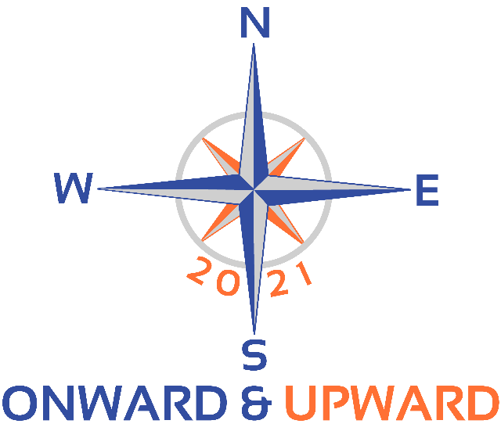



**The St. Paul Squadron Invites You**

**District 10 Fall Conference**

**November 5 - 6 - 7, 2021**

**Metropolis Resort**

**Eau Claire, Wisconsin**

**Registration**



**Rank _________ Name _________________________________________________ Grade _________­_**

**Rank _________ Name _________________________________________________ Grade _________­_**

**Squadron ____________________________ Sq Position/Job/Dept/Role __________________________**

**Phone(s) ____________________________ E-mail ___________________________________________**

**Children’s Names & Ages** _________________________________________________________________

|  |  |  |  |
| --- | --- | --- | --- |
| **EVENT** | **Cost** | **Number** | **Total** |
| **Friday** **Night Buffet**: Burger/chicken/brat on roles, baked beans, chips, slaw,  brownie, iced tea | **$ 21** | ______ | $________ |
| **Saturday Lunch Buffet:** Soup/salad/breadsticks (chicken & wild rice soup, build-  your-own salad w/dressing, breadsticks, iced tea | **$ 13** | ______ | $________ |
| **Saturday Dinner Buffet:** Plated house salad, roasted beef in mushroom gravy,  glazed chicken, carrots, baby red parsley potatoes,  coffee or iced tea, assorted dessert bars | **$ 28.50** | ______ | $________ |
| **Sunday Breakfast Buffet**: Scrambled eggs, ham, breakfast potatoes, English  muffins butter & jam, apple or orange juice | **$ 13** | ______ | $________ |
| **Kids’ Meals:**  *Please indicate selection, quantity and at which meal(s) - F,SL,D,B.*  Chicken Strips, applesauce, fries: Qty ___ Meal(s) _____________  Mini Corndogs, applesauce, fries: Qty ___ Meal(s) _____________  8” Cheese Pizza, applesauce: Qty ___ Meal(s) _____________ | **$ 13** | ______ | $________ |
| **Special Dietary Requests:** *We’ll do our best to meet your requirements for gluten-free or vegetarian modifications. Please register for a meal above and indicate your requests here:* **___________________________________________** |  |  |  |
| **Saturday Educational Seminar:** Using GPS | **$ 25** | **______** | $________ |
| **Sunday Educational Seminar:** Partner in Command | **$ 25** | **______** | $________ |
| **All-Day Action City Pass – Per Person, Per Day** *This is the advance purchase group price; passes purchased from the hotel will be $31.00 per person, per day.* | **$ 15** | **______** | $________ |
| **TOTAL** |  |  | **$______** |

**Please help us plan! Insert the initials of each registrant who is likely or planning to attend each of these events.**

|  |  |  |  |  |  |
| --- | --- | --- | --- | --- | --- |
| Sat: Regionalizing ABC |  | Sat: Intro to New D10 Website |  | Sun: Breakfast with the Bridge |  |
| Sat: Conference Meeting |  |  |  | Sun: Boating Tips & Tricks |  |

***See next page for registration options.***

**Click here to register and pay online.**

**OR**

**Mail form and check to:**

**P/C Nancy Gagich**

**2334 Boulder Road**

**Chanhassen, MN 55317**

**(952) 934-5978**

**Make checks payable to:**

**St. Paul Sail & Power Squadron**

**Registration Deadline is Tuesday, October 26!**

**Questions?**

[**mailto:ngagich@mschi.com**](mailto:ngagich@mschi.com)

[**mailto:klharmon@comcast.net**](mailto:klharmon@comcast.net)

**Hotel Information: Group Rate Reservation Deadline: *Friday, October 15.***

**Metropolis Resort**

5150 Fairview Drive

Eau Claire, WI 54701

**(844) 845-2724**

* *I94 at exit 68*
* *In-room mini-fridge & microwave*
* *Connected to Chaos Water Park &*

*Action City Amusement Park*

Ask for the

***District 10 Fall Conference block rate of $109*** for room with king bed or two queens.

*A Resort Fee of $13.99 will be added for each night. (Fee includes Chaos Water Park passes, Wi-Fi, parking, phone calls, business center use.)*

[***https://www.metropolisresort.com***](https://www.metropolisresort.com)

*Rooms reserved after 10/15 will be $159.00 – IF available.*

**All Apparel is Welcome! – Suggested Attire?**

**Friday Evening**: America’s Boating Club / USPS Casual

**Saturday:** America’s Boating Club / USPS Casual

**Saturday Evening**: Business Casual or ABC/USPS Casual

**Sunday:** America’s Boating Club / USPS Casual

**Bizarre pre-Christmas Bazaar**

**No idea what to get for your favorite uncle?**

Remember those knobby yellow mugs from your niece? or the kangaroo-fur purse you aunt gave you after she went to Australia? that new 1000-piece puzzle you’ll never get to? the wine glasses you bought but never used? We’ll be offering great prices on items like these and others that have been sitting unused in our cupboards and closets.

Stop by! Take a look! Buy! You might find something that will be your cousin’s heart’s desire!

[We will happily accept any contributions. Just bring them to the registration desk. Thanks!]

*Proceeds will go toward Fall Conference costs or Toys for Tots. Receipts confirming your charitable contribution will be available upon request.*

**Sunday Morning**

**Before You Go . . .**

Participate in the now traditional Sunday morning Breakfast with the Bridge – to talk about the Conference, to ask questions, to share your thoughts about ABC and District 10.

Finish the morning with one more seminar or the new, informal roundtable to share boating tips, tricks, adventures and more!